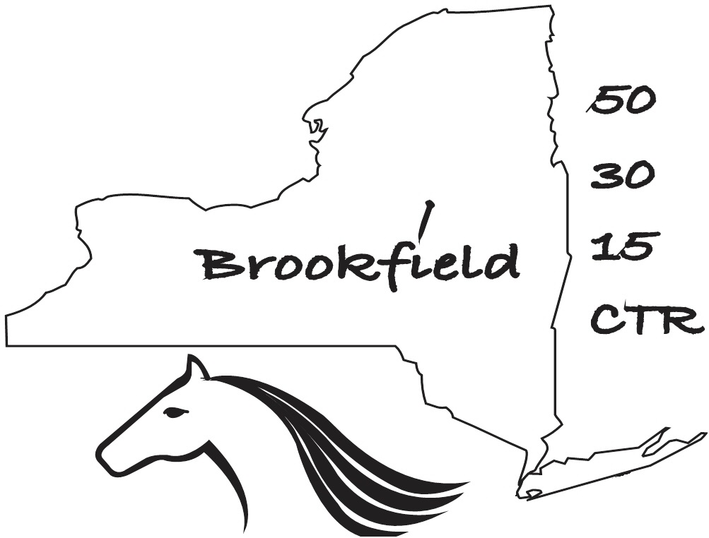
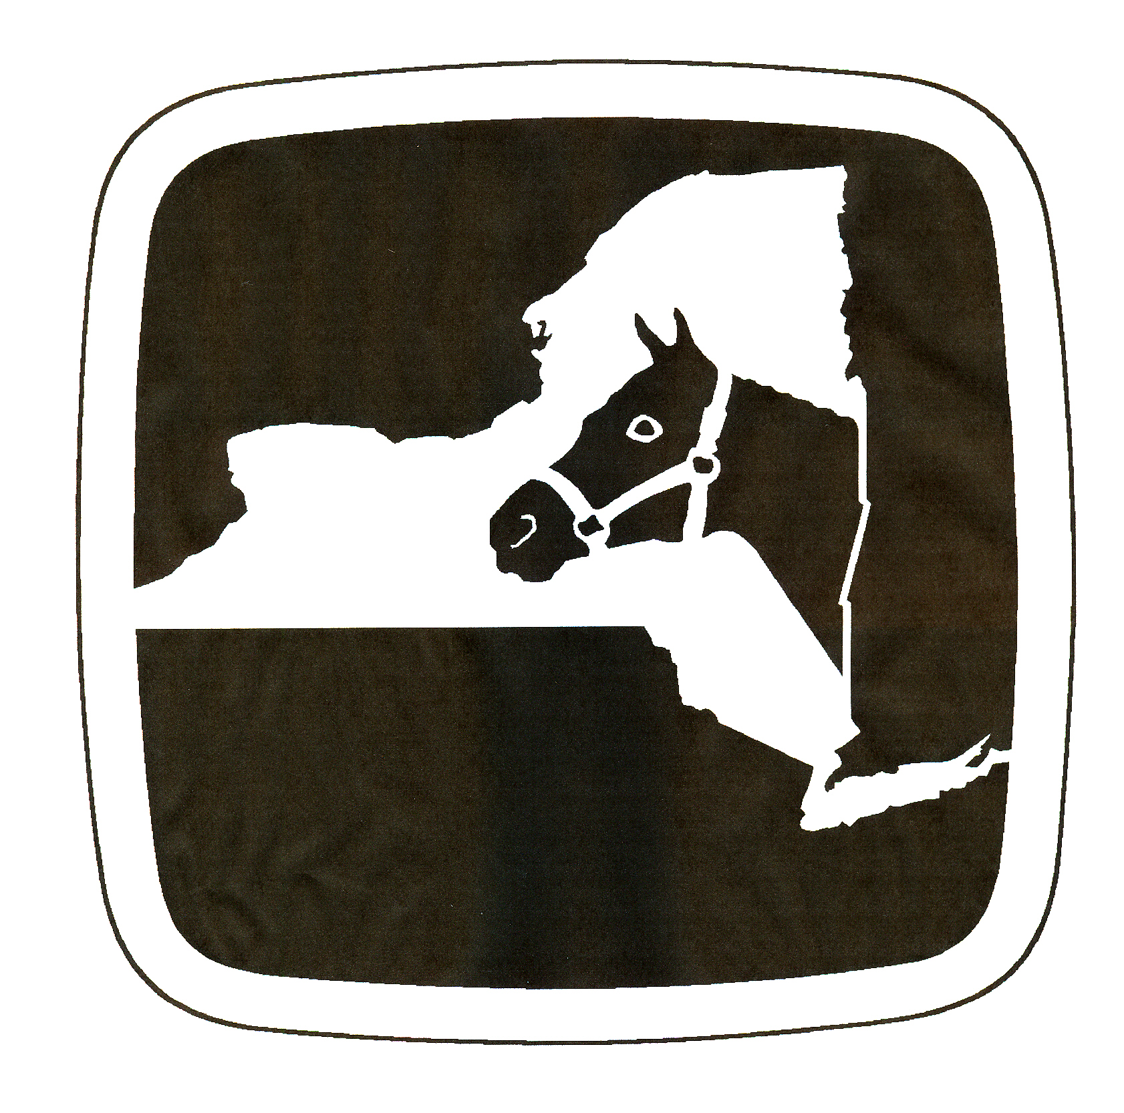
NY 50/30/15
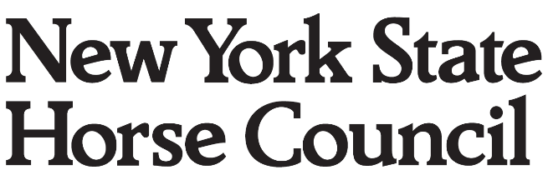
Competitive Trail Ride Clinic
May 06, 2017
Pure Country Campground
New Berlin, NY
www.brookfieldctr.weebly.com
Participant
Name______________________________________________________Jr._______Sr.______
Address____________________________________________________Age if Jr._________
City______________________________State_____Zip_________Tel #_________________
E-mail_____________________________________________ECTRA #____________________
Horse_

Name Breed Age Sex ECTA # Owner
FEE
The unmounted clinic fee is $10.00. For mounted attendees, the fee is $20 which includes horse camping with a spot for your rig at Pure Country Campground(PCC).

This liability release and agreement must be signed and returned with your entry. No cross outs or additions are permitted.
In consideration for permission to enter and participate in the New York 50/30 Competitive Trail Riding Clinic I do hereby for myself, my heirs and assigns, release and hold harmless Clinic Management, Clinic volunteers, NYSHC, ECTRA, Pure Country Campground, and their agents, officers, servants, employees and officials, from all claims, demands, actions and causes of action of any kind, for injury or death sustained by me and damage to my property, incurred during this clinic arising from negligence or any other fault. “Clinic” includes from the time I arrive at the clinic until the time that we leave the premises, as well as the actual event.
I understand that horses are unpredictable and can be dangerous. I am aware that as a result of participating in the clinic I may be injured, die or my property damaged.
In the event that the participant initiates a lawsuit against clinic management, clinic volunteers, NYSHC, ECTRA, Pure Country Campground, and their agents, officers, servants, employees and officials as a result of his/her participation in the clinic, and said participant fails to establish liability or fault of the above-named entities, the undersigned agrees to pay all litigation costs and legal expenses incurred by the above-named entities in defending said lawsuit. It is further agreed that the above-named entities may assign their right to recover legal fees and expenses to their insurance carrier.
I agree to take full responsibility for myself. I recognize that my participation in the clinic is voluntary.

I HAVE READ AND UNDERSTAND THE ABOVE LIABILITY RELEASE AND AGREEMENT, AND AGREE TO BE BOUND BY ITS TERMS AND CONDITIONS.

Participant’s signature
_

Guardian signature (if Junior)
_

Horse Owner’s signature
_
Directions to Pure Country Campground (PCC)Do Not use your GPS directions!
Go to the PCC website: www.PureCountryCampground.com
Near the top right of the page is a login oval. Just below and left of this is the word directions. Click this link to get to the next page. Scroll down to the bottom of that mostly blank page and click the small sentence that says, “Click here to get turn-by-turn driving directions.”
This will take you to a map and directions page. Insert your starting point then click search. It will give you good directions to the campground.
For information about or to register for the clinic contact:
Dan Gruen, Clinic Manager OR Joanna Lasher, Clinic Secretary, 292 Hermance Rd. Galway, NY 12074
BrookfieldCTR@roadrunner.com JoLasher65@gmail.com
(315) 749-8086 (518) 882-1515
Make checks payable to Dan Gruen, NY 50/30/15 and mail to the above address.
Confirmation of your entry will be by e-mail.

